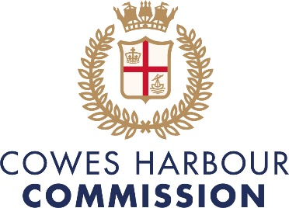

COWES HARBOUR COMMISSION BOARD VACANCIES

Cowes is the main port/gateway to the Isle of Wight, and historic home of British yacht racing. The Harbour Commission is now looking for two new commissioners to join the board of this busy harbour. These are both voluntary positions to complete a board of nine enthusiastic team players at a time of exciting changes and opportunities in the harbour.
The number one responsibility of the Commissioners is the safety of the harbour and to maintain and run the harbour for the benefit of Cowes Harbour stakeholders and the local community. Our proactive approach to environmental and sustainable initiatives has already seen the installation of marine electric chargers at our public pontoons, seagrass protection and oyster repopulation projects in the Harbour. Other recent developments have included an apprentice and bursary programme for local young people wanting to follow a marine career and initiatives to digitise the customer experience of the Harbour including phone-based payments and a new Web app for the Harbour and Cowes High Street.
A safe and well-run harbour is the commission’s primary focus and we have a broad range of commercial and leisure activities in the Harbour. Ferries and commercial ships enter the harbour 24/7 carrying freight, vehicles and approximately three million passengers per annum; and bulk shipping and large commercial vessels traverse the Harbour to the river Medina. A number of high-end cruise ships visit every year and the Harbour is always busy with local, national and international sailing events and racing, both power and sail.
So, if you would like the chance to help shape the future development of the Harbour, positively contribute to the local community, be part of a dynamic and proactive board, and you have good commercial skills, then we would like to hear from you.
The Role
The board of commissioners consists of nine independent non-executive commissioners, the Chief Executive and the Harbour Master, led by the chair. The commissioners are appointed on merit on an open recruitment basis to provide CHC with the professional skills and experience to determine the policy and business decisions of the organisation. Along with other board members you will oversee the governance, strategy and performance of the Harbour and its associated operations.
This is a voluntary position with eight Friday morning Board meetings a year plus ad hoc project work and two Board dinners. Reasonable expenses can be reimbursed.
Experience
Senior management or board level experience is desirable.
Whilst a good operational business background is important, it would be an advantage to hear from anyone with financial and/or commercial property development experience.

Time commitment
Commissioners are expected to attend eight Board meetings a year, held on a Friday morning. Commissioners also attend the public Annual General Meeting, as well as two informal dinner meetings a year.
Ad hoc and occasional support through working groups and / or support to the executive team.
Term
The commissioners are appointed for a term of three years and can usually serve a maximum of two terms.
Please contact chc@cowes.co.uk for further information on Cowes Harbour Commission and an application form should you wish to apply.

