Cowes Harbour Commission 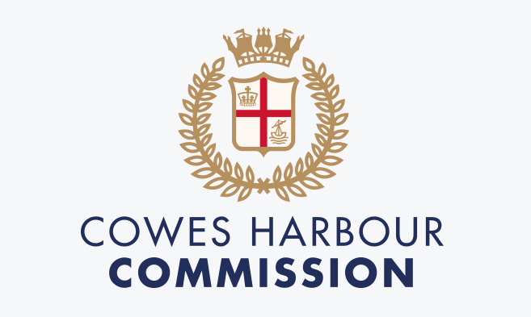

JOB DESCRIPTION

Post Title: | Port Operative- Boatyard/Marina
Department: | Marine Services
Reports To: | Marine Services Manager for all line management responsibilities
Job purpose: | - Assist with all day-to-day boatyard/marina operations within CHS sites.  - To be a hands-on member of the CHS lifting team  - Engage with all boatyard stakeholders to ensure compliance with the site Code of Conduct/Working Procedures  - Respond to emergency situations within Cowes Harbour
Primary Responsibilities: | Shared Organisational Responsibilities  - Promote and deliver a safety-first culture ensuring the highest standards in health and safety for CHC colleagues and harbour users  - Promote and role model the organisation’s values at all times  - Ensure the delivery of CHC’s financial objectives, adopting a commercial mind-set and actively seeking revenue generating opportunities  - Ensure an exceptional customer experience, putting the customer at the heart of all actions and decisions  - Take responsibility for personal development and delivery of agreed objectives responding positively to feedback and coaching to improve performance  - Act as an ambassador and represent CHC on all appropriate local, regional and national events and forums relevant to the post  Functional Responsibilities  Port Operative – Boatyard Health & Safety Operations  - Act as a member of the CHS Marine Services Operations Team which includes but not restricted to:  - CHS Lifting Operations  - Operating CHS Plant & Machinery  - Carrying out CHS Labour Jobs as instructed by Team Leader  - As part of the CHS lifting teams you will be required to have the following qualifications:  - Hoist Operator  - Boatmover Operator  - Mobile Crane Operator  - Slinger/Banksman  - As part of the CHS lifting team you will be required to work as part of the lifting team at both Kingston & Shepards as instructed.  - Actively engage with boatyard customers and contractors to ensure compliance with current CHS Health & Safety Site Code of Conduct.  - Undertake any in house or external training as requested.  - Strictly adhere to all CHS site safety and operating procedures.  - Raise any matters concerning the safe operation of site to the immediate attention of the MSM or CHC Management.  - Assist the Team Leader with ensuring the site housekeeping is kept to a high standard.  Boatyard/Marina Inspection and Maintenance  - Undertake regular inspection and ensure documented procedures are always followed in:  - All CHS cradles, stands & chocks are checked and in good order as per CHS PUWER Policy and PMS  - All CHS strops, shackles, chains are checked and in good order as per our PUWER Policy and PMS  - Carry out scheduled checks on all boats stored in the yard, especially before/after high winds to ensure no movement or damage.  Customer Contact  - Positively engage with all CHS stakeholders to ensure a high level of customer care and satisfaction  Incident Management  - Respond to any incident within the Harbour as per instruction from CHC Management
Other Duties | - At all times ensure that working practices are in line with the requirements of CHC’s Health and Safety Policy and generally seek to ensure the safety of CHC’s employees, partners, tenants, visitors and customers.  - To support the wider CHC team when required for events over and above the normal day-to-day running of the organisation ensuring that commercial opportunities are maximised.  - To actively engage with any special projects and annual events / large public festivals that occur from time to time over and above the normal day to day running of the operation ensuring that all commercial opportunities are maximised.  - Any other duties that fall within the scope and spirit of the post.
Key Measures of Performance | - CHS safety statistics  - MSM Appraisal  - Customer feedback  - Colleague feedback
NB. The nature of the post may require a commitment to CHC outside of normal working hours (e.g. weekends, evenings, Bank Holidays, etc.). Out of hours working will be compensated in line with CHC policy.
Post holders will be accountable for carrying out all the duties and responsibilities with due regard to the CHC’s Health and Safety and Equal Opportunities Policies.
Duties, which include processing of any personal data, must be undertaken within CHC’s data protection guidelines and in line with current data processing legislation e.g. GDPR.

PERSON SPECIFICATION
Assessment for recruitment requirements and competencies

Aptitudes, skills and abilities | Essential  - Flexible and able to multi-task  - Good verbal and written communication skills  - Self-motivated, enthusiastic and with a positive can-do attitude  - Confident and passionate about customer service  - Can remain calm in stressful situations  - Able to work well alone and as part of a team  - Able to develop good relationships with other river stakeholders
Knowledge and experience | Essential  - Experience of working in a marine or similar environment  - Experience in customer service and customer facing roles  - Computer literate  - Experience in planning and good organisational skills  Desired  - Experience in following Health & Safety procedures
Education and qualifications | - Evidence of GCSE Maths and English at Grade C or above  - Powerboat Level 2  - Emergency First Aid
Special Requirements: | - This post is exempt from the provisions of the Rehabilitation of Offenders Act 1974. A Criminal Record Disclosure may be required prior to appointment.  - Eligibility to work in the UK.

