Cowes Harbour Commission 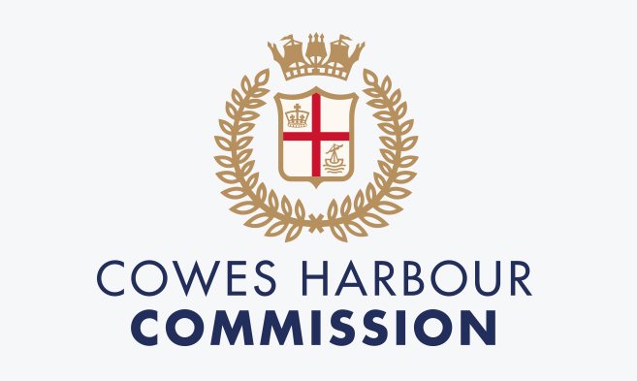

JOB DESCRIPTION

Post Title: | CHC Water Taxi Operative
Department: | Marine Services
Reports To: | Patrol Officer Team Leader for all line management responsibilities (non-statutory) and Deputy Harbour Master / Harbour Master for all statutory responsibilities and incident management
Job purpose: | - Operate the CHC Water Taxi service in accordance with CHC guidelines.  - Engage with all stakeholders to educate and ensure enforcement of the Harbour’s General Directions and other Regulations  - Provide assistance and advice to vessels for any navigation/safety issues and any available moorings  - Respond to emergency situations within Cowes Harbour  - Ensure the timely and accurate collection of mooring fees from vessels using any of Cowes Harbour moorings or anchorages.
Primary Responsibilities: | Shared Organisational Responsibilities  - Promote and ensure a high standard of customer service culture across all CHC sites, putting the customer at the heart of all actions and decisions.  - Promote and role model the organisation’s values at all times.  - Promote and deliver a safety-first culture ensuring the highest standards in health and safety for CHC colleagues and harbour users  - Take responsibility for personal development and delivery of agreed objectives responding positively to feedback and coaching to improve performance  - Act as an ambassador and represent CHC on all appropriate local, regional and national events and forums relevant to the post  Functional Responsibilities  Water Taxi service  - Carry out Water Taxi service throughout the Cowes Harbour area  - Ensure that all journeys are conducted in a safe manner, with observance of the General Directions and good seamanship  - Ensure that all passengers pay for their respective journeys  - Ensure that CHC customers receive a high level of good customer service  - Ensure that all journeys are recorded in the taxi log  - Log maintenance of all harbour taxi vessels  - Assist with the enforcement of the Cowes Harbour General Directions along with any other directions issued by the Harbour Master.  - Wear the CHC-provided uniform and safety clothing at all times whilst on duty.  Harbour Inspection and Maintenance  - Report any identified issues with the following:  - All CHC residential and visitor pontoons and piles  - All CHC residential and event swinging moorings  - All Aids to Navigation  - CHC river signage  - Assist with undertaking regular inspection and cleaning of all CHC tidal gauges to ensure safe navigation of vessels  - Assist with undertaking and logging regular checks on all river pontoons, checking the condition of customers boats and lines, as required. Log findings, inform line manager and boat owners of any issues and escalate significant issues as appropriate  - Assist with undertaking non-emergency tows of vessels within the Harbour, as required  - Assist with berthing within the Harbour including Shepards Marina, as required  - Provide assistance to CHC Patrol team as and when required.  Customer Contact  - Assist with collecting mooring fees from visitors and account for monies taken on Harbour Assist  Incident Management  - Respond to any incident within the Harbour including the investigation of pollution reports, as required  - Log and collate information on any CHA incidents and report findings through appropriate channels
Other Duties | - At all times ensure that working practices are in line with the requirements of CHC’s Health and Safety Policy and generally seek to ensure the safety of CHC’s employees, partners, tenants, visitors and customers.  - To support the wider CHC team when required for events over and above the normal day-to-day running of the organisation ensuring that commercial opportunities are maximised.  - To actively engage with any special projects and annual events / large public festivals that occur from time to time over and above the normal day to day running of the operation ensuring that all commercial opportunities are maximised.  - Any other duties that fall within the scope and spirit of the post.
Key Measures of Performance | - Water Taxi hours of operation and number of customers carried  - Revenue collection  - Customer feedback  - Colleague feedback
NB. The nature of the post may require a commitment to CHC outside of normal working hours (e.g. weekends, evenings, Bank Holidays, etc.). Out of hours working will be compensated in line with CHC policy.
Post holders will be accountable for carrying out all the duties and responsibilities with due regard to the CHC’s Health and Safety and Equal Opportunities Policies.
Duties, which include processing of any personal data, must be undertaken within CHC’s data protection guidelines and in line with current data processing legislation e.g. GDPR.

PERSON SPECIFICATION
Assessment for recruitment requirements and competencies

Aptitudes, skills and abilities | Essential  - Flexible and able to multi-task  - Good verbal and written communication skills  - Self-motivated, enthusiastic and with a positive can-do attitude  - Confident and passionate about customer service  - Can remain calm in stressful situations  - Able to work well alone and as part of a team  - Able to develop good relationships with other river stakeholders
Knowledge and experience | Essential  - Proven boat handling skills  - Experience or working in ports, harbours or a marine environment
Education and qualifications | Essential  - Evidence of GCSE Maths and English at Grade C or above  - RYA Powerboat Level 2  - RYA First Aid or equivalent  - RYA VHF Licence  Desired  - Boatman’s Licence  - RYA Advanced Powerboat with Commercial Endorsement
Special Requirements: | - This post is exempt from the provisions of the Rehabilitation of Offenders Act 1974. A Criminal Record Disclosure may be required prior to appointment.  - Eligibility to work in the UK.

